Assignment 3

Qi Guo

Fixes:

1. Added ewExhibition, ewStartDate and ewEndDate in ExhibitionsWorks as foreign keys to Exhibitions table

2. Added a new attribute named elExEndDate as end date to ExhibitionLocation table

3. Added data to elExEndDate column

4. Added an Owners table and populated data in it

5. Removed wkOwner column from Works table since the data were already stored in Owners table

6. Added a new attribute named lcMuseum to Locations table

7. Dropped old pk for Locations table and add lcNuseum and lcName as new set of pks.

8. Added new attribute regarding lcMuseum attribute in Locations table to Doors, WorksLocations, ExhibitionsLocations tables

9. Added foreign keys to Doors, WorksLocations, ExhibitionsLocations tables referencing Locations table

10. Attached is the e-r diagram before part 1

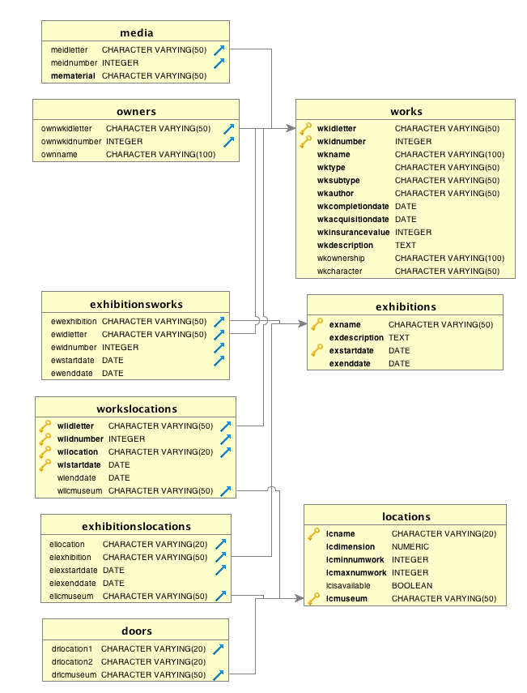

**Routine Maintenance**

1. Expanding current exhibitions
   1. Creating a view named WorksInMuseum to record all borrowed or owned works since potential works are not in museum yet
   2. Create a view named WorksHaveNotBeenUsed to get all works that have not been used before
   3. Created a report of all current and future exhibitions with exhibition name, starting and ending dates, maximum recommended capacity of the locations it is using and the current number of works planned for it
   4. Added works to exhibitions that are under way first since those works need to be added to corresponding exhibitions on October 28.
   5. Added works to exhibitions that have not yet started.
   6. Updated WorksLocations and ExhibitionsWorks tables accordingly.
   7. E-R diagram after this part is pasted below

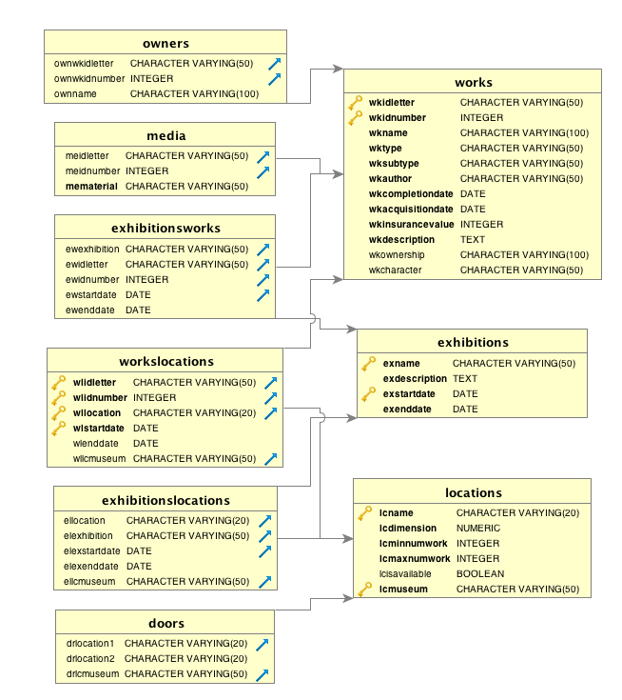

1. Evolving collection
   1. Since there are 15 additional new works bought on October 25, these works are added to Works table as ‘owned work’ as ownership; added to Owners table with my museum ‘Qi’s Museum’ as the owner name; added to storage in WorksLocations table with ‘2016-10-25’ as the start date.
   2. 3 works need to be sold to other museums. But I only have one work that has never been exhibited and currently in storage. So I used that one along with two newly added works (with insert date ‘2016-10-05’) as sold works. So worksLocations table was updated with end date of ‘2016-10-21’; Owners table has been updated with ‘sold to another museum’ as owner name (since it is unknown for now); Works table has been updated with ‘sold work’ as new ownership.
   3. There is no need to update database structure for this part, so the e-r diagram is the same as the previous one

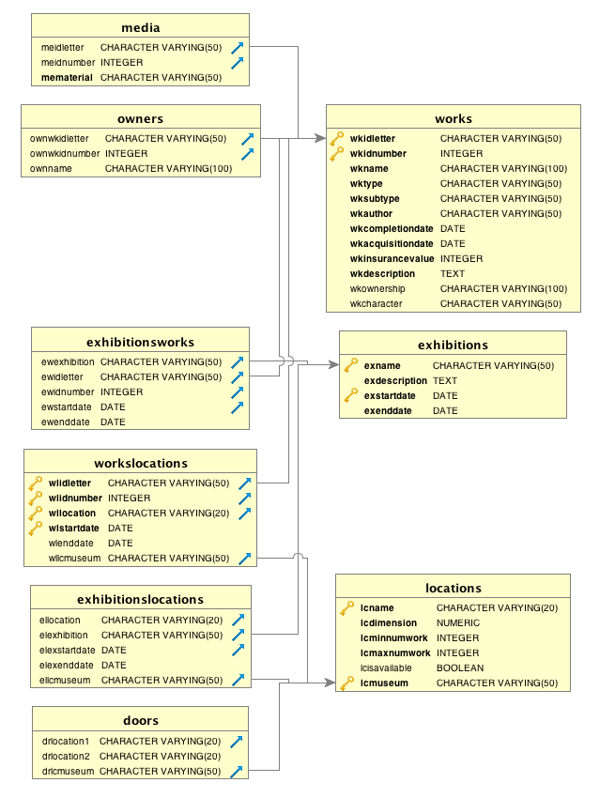

1. Recording history
   1. Altered domain exhibitionStartDate and exhibitionEndDate since they were set to be greater than ‘2016-07-01’, which is not suitable for this part. So the new domain is checking whther they are greater than ‘2000-01-01’.
   2. Altered domain for wlstartdate and wlenddate for WorksLocations from date type to timestamp type and set it to ‘2000-01-01’.
   3. Added three one/room exhibitions that occurred prior to 2016-07-07
      1. Add data to exhibitionsworks table
      2. Add data to exhibitioinslocations table
      3. Add data to WorksLocations to set corresponding data for location switching (from storage to exhibition or from exhibition to storage)
   4. Wrote three queries to check the correctness for part 3
      1. Produce a query that lists the different locations that a given work was/is/will be in between two dates
      2. Produce a query that lists all the works found in an exhibition between two dates
      3. Produce a query that lists all the exhibitions that make use of a location between two dates
   5. E-r diagram after this part is pasted below

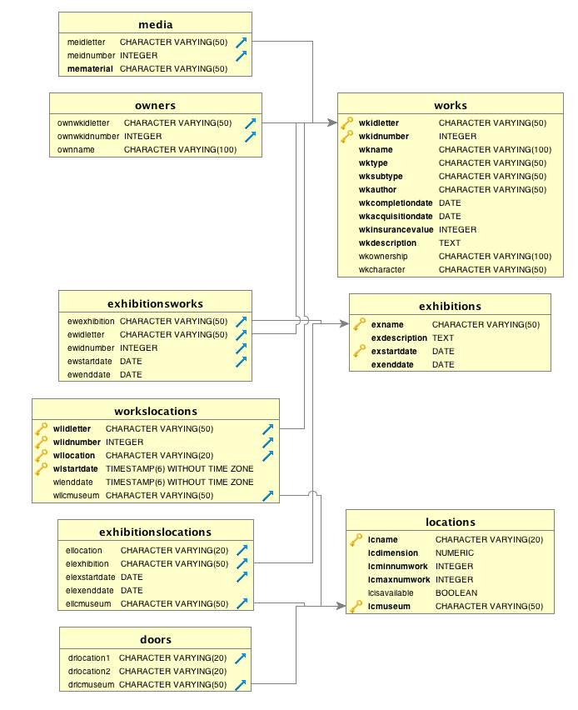

1. Get all pks and work names for available works between 2016-11-01 and 2017-04-30 since they are all in storage
   1. Create domains for LoanedWorks table
   2. Create a new table named LoanedWorks to keep track of all loan information
   3. Insert data into LoanedWorks table
   4. Add locations to locations table
   5. Add data to WorksLocations table
   6. Modify the datetime for these works in storage

